Safe Work Method Statement (SWMS)
  PHONE: 0412 562 884 FAX: (03) 9462 0160 |  | This SWMS has been developed and authorised by:
 |  | Name: | Leo Butera
 |  | Position: | Managing Director | Date: | 10/02/2015
 |  | Signature: | Leo Butera | Phone: | 0412 562 884
 |  | Signature: | Leo Butera | Mobile: | 0412 562 884
Description of Work Activity: Gyprocking / Plastering to Walls & Ceilings
Trades involved with undertaking this work activity: Gyprockers
This SWMS is submitted to (principal contractor):
Company: Pro Design Projects P/L
Contact Name: Leo Butera | Contact Name:
Site Address: | Project Description: Gyprocking / Plastering to Walls & Ceilings
This SWMS is reviewed by (principal contractor):
Name: Leo Butera | Position: Managing Director
Signature: Leo Butera | Date: 27/02/18
Phone Number: 0412 562 884 | Mobile Number: 0412 562 884
Person responsible for supervising and implementing on this contractor’s behalf, the WHS controls associated with each step of this work activity:
Name:
Signature: | Date: 21.02.18
Phone Number: | Mobile Number:

List plant, equipment and tools to be used | List hazardous substances to be used or handled | MSDS available? (Tick) | List PPE to be used |  | Tick | List hazards to consider | Tick
Mobile Scaffold | Base Coat | √ |  | Hard Hat | √ | Fall from ladder | √
Step Ladders | Stud Adhesive | √ | 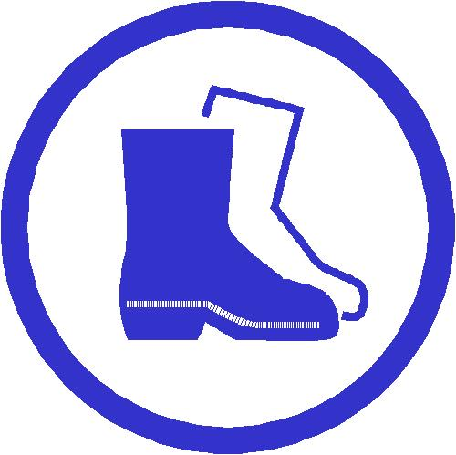 | Safety Footwear | √ | Fall from heights | √
 |  |  |  | Eye Protection |  | Fall from scaffold | √
 |  |  | 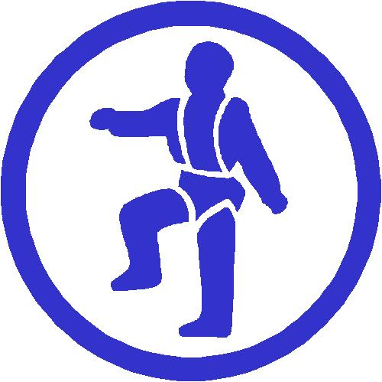 | Safety Harness |  | Contact with electricity | √
 |  |  | 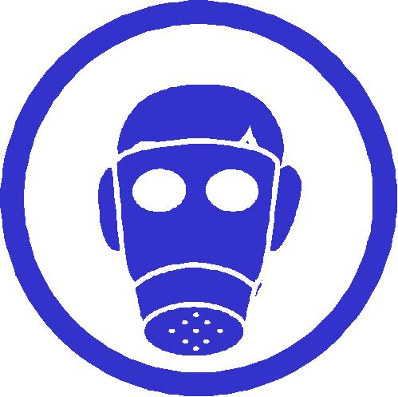 | Respiration Equipment |  | Falling objects | √
 |  |  | 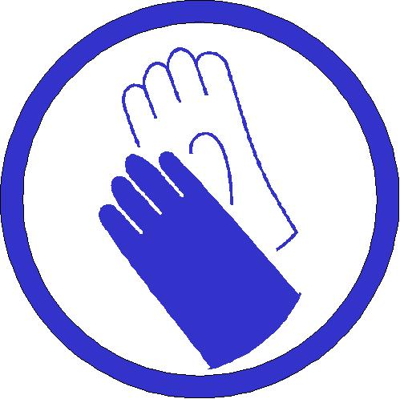 | Hand Protection |  | Collapse | √
 |  |  |  | Ear Protection |  | Slip, trips and falls | √
 |  |  | 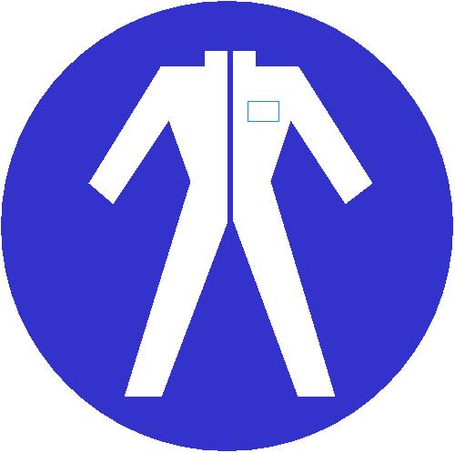 | Overalls | √ | Manual Handling | √
 |  |  | 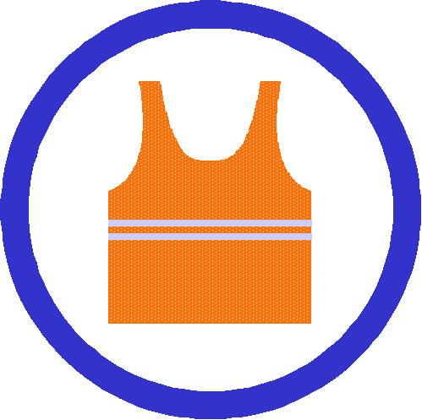 | Illuminating Safety Vest | √ | Exposure to noise | √
 |  |  |  | Wet Weather Gear |  | Struck by moving plant | √
 |  |  |  | Sun Glasses |  | Inhalation of dust or fumes | √
 |  |  |  | Hat |  | Cuts
 |  |  |  | Sun Screen |  | Other (specify):
 |  |  |  | Other (specify):

 | How to complete the following form  - List the step-by-step sequence of tasks required to carry out a work activity from start to finish.  - List the potential hazards associated with each step, and the related OHS risks.  - Using the risk table, rate the identified risks.  - List what controls you will implement to reduce the risks to the lowest possible level.  - Rate the level of risk once those controls have been implemented (must be 4-6 before you can start work).  - List the names or positions of the persons responsible for ensuring that the controls are implemented.  A separate SWMS is required for each work activity.
  RISK TABLE |  | How likely is it to be serious?  NOTE: If a hazard is rated 1, 2 or 3, take action immediately.
  RISK TABLE | What damage could it cause? | Very likely  (could happen anytime) | Likely  (could happen sometimes) | Unlikely  (could happen, but only rarely) | Very unlikely  (could happen, but probably never will)
  RISK TABLE | Death or permanent disability | 1 | 1 | 2 | 3
  RISK TABLE | Long term illness or serious injury | 1 | 2 | 3 | 4
  RISK TABLE | Medical attention and several days off work | 2 | 3 | 4 | 5
  RISK TABLE | First aid needed | 3 | 4 | 5 | 6

CEILINGS:

Step | Activity step  Break the activity down into steps. List the steps in this column. | Hazards identification  Identify any potential hazards associated with each step – and any related risks. Detail the hazards and risks in this column and enter the risk rating in the next column. | Initial risk rating (1-6) | Controls implemented  Decide what controls to use to eliminate or minimise the risks. Detail the controls in this column, and enter the revised risk rating in the next column. Note: If the risk rating is still 1-3, do not begin work. | Revised risk rating (1-6) | Person responsible
1. | Issue Personal Protective Equipment | Head, Hand, Foot & Body Injury | 2 | Ensure site personnel have received & signed for relevant PPE | 6 | LB
2. | Establishment of site, positioning of tools, plant & equipment | Manual handling, possible back strain, impact injury etc | 2 | Ensure site personnel have been instructed in manual handling techniques.  When available material to be unloaded using site crane or forklift. Additional labour to carry heavy/long material. Use trolleys for maneuvering material on floor | 6 | LB
3. | Set out ceiling grid  Fix ceiling hangers | Falling when working at heights  Electrocution | 2  1 | Ensure site personnel have been instructed in safe use of ladders and mobile scaffolds  Ensure site personnel have been instructed in safe use of electric drills  Ensure ELCB / RCD Extension cords have been tagged and tested | 6  5 | LB  LB
4. | Install ceiling grid | Cuts to hands | 3 | ensure site personnel have been trained in safe use of hand tools. If required use appropriate hand protection eg gloves | 6 | LB
5. | Fix ceiling lining | Back strain/ impact injury | 3 | Ensure site personnel have been instructed in manual handling techniques | 6 | LB
6. | Set joints | Falling | 2 | Ensure site personnel have been instructed in safe use of ladders and mobile scaffolds | 6 | LB
7. | Sanding of joints | Dust installation | 3 | Where applicable mechanical sander with dust extraction system to be used. Ensure site personnel have been instructed in safe use of electric drills.  When hand sanding correct dust mask must be worn. | 6 | LB

WALLS:

Step | Activity step  Break the activity down into steps. List the steps in this column. | Hazards identification  Identify any potential hazards associated with each step – and any related risks. Detail the hazards and risks in this column and enter the risk rating in the next column. | Initial risk rating (1-6) | Controls implemented  Decide what controls to use to eliminate or minimise the risks. Detail the controls in this column, and enter the revised risk rating in the next column. Note: If the risk rating is still 1-3, do not begin work. | Revised risk rating (1-6) | Person responsible
1. | Issue Personal Protective Equipment | Head, Hand, Foot & Body Injury | 2 | Ensure site personnel have received & signed for relevant PPE | 6 | LB
2. | Establishment of site/material delivery | Manual handling, possible back strain, impact injury etc | 2 | Ensure site personnel have been instructed in manual handling techniques  When available material to be unloaded using site crane or forklift. Additional labour to carry heavy/long material. Use trolleys for maneuvering material on floor | 6 | LB
3. | Set out ceiling grid  Set out and fix top & bottom track | Falling when working at heights  Hand & body injury if using EPT eg ramset gun | 2  2 | Ensure site personnel have been instructed in safe use of ladders and mobile scaffolds  Ensure all personnel have been instructed in safe use of electric power tools | 6  6 | LB  LB
4. | Erect steel stud framing. as required use friction saw (drop saw) for cutting materials to size | Hand, face & body injury  Electrocution | 2  1 | Ensure correct PPE is worn eg ear, eye protection  As required cut studs by hand | 6  5 | LB  LB
5. | Install door frames & noggins  Line side 1  Mechanical Plant | Back strain & impact injury  Electrocution when using electric hand tools eg drills | 2  1 | Ensure site personnel have been instructed in manual handling techniques  Use additional manpower to lift long sheets. Work platforms to be set at the correct height & position to avoid overreaching  Ensure all personnel have been instructed in safe use of electric power tools | 6  5 | LB  LB

Safe Work Method Statement (Part 2)
Personal Qualifications and Experience: | Personnel, Duties and Responsibilities: |  | Training Required to Complete Work:
Gyprocking Installers | Work under supervision of site foreman |  | Ongoing safety training by way of Tool Box Meetings
OH&S General Induction Card
Engineering Details/Certificates/WorkCover Approvals: N/A |  | Codes of Practice, Legislation:
 |  | Refer to attached form.
Plant/Equipment: Mobile Scaffold, Step Ladders |  | Maintenance Checks:
 |  | Ensure all equipment is visually inspected every morning to ensure it is in correct working condition.
Read & Signed by All Employees on Site: Refer to attached declaration

RELEVANT LEGISLATION, CODES OF PRACTICE & AUSTRALIAN STANDARDS

RELEVANT LEGISLATION | CODES OF PRACTICE | AUSTRALIAN STANDARDS
OCCUPATIONAL HEALTH AND SAFETY AND WELFARE ACT 2004.  ACT AND REGULATIONS  CODES OF PRACTICE  WORK HEALTH & SAFETY ACT 2011 | HAZARDOUS MANUAL TASKS | AS/NZS 1891.1:2007 – INDUSTRY FALL ARREST SYSTEMS AND DEVICES
WORK HEALTH & SAFETY REGULATION 2011 | HOW TO MANAGE WORK HEALTH & SAFETY RISKS
 | MAKING NOISE AND PREVENTING HEARING LOSS AT WORK
 | MANAGING THE RISK OF FALLS AT WORKPLACES
 | MANAGING THE WORK ENVIRONMENT AND FACILITIES
 | FIRST AID IN THE WORKPLACE
 | WORK HEALTH AND SAFETY CONSULTATION, CO-OPERATION AND CO-ORDINATION
COMMENTS

Declaration by contractors and workers |  |  | Yes No
I have been consulted and have assisted in the development of this SWMS.
I have been given the opportunity to comment o the content of this SWMS.
I have read and understand how I am to carry out the activities listed in this SWMS.
I have been supplied with the Personal Protective Equipment identified on this SWMS and I have been given training in the safe use of this equipment.
I have read and understand the requirements set out in the Material Safety Data Sheets for the Hazardous Substances identified in this SWMS
Name | Signature | Date

Number | Requirements | Action

ANY OTHER REQUIREMENTS ETC

